

**Kolbe Catholic College**

**Year 8 Science**

**Task 4: BouncingBall Investigation**  **Due: ________________________**

**Part B: Validation Test (45 Minutes)**  **Mark: _____ /24 Marks**

Student Name: _________________________________

Teacher: _________________________________

**Investigating the Efficiency of Bouncing Balls**

Energy appears in different forms. When a ball is dropped, a number of energy transfers and transformations occur.

No transformations are 100% efficiency. Each time energy is transformed from one form to another, energy is lost. To calculate the efficiency of the bounce of the ball, we can use the following formula:

***Energy Efficiency = Rebound height of first bounce***

***Initial height above the ground***

**Question 1**  **Variables**  **(2 Marks)**

For the experiment which you conducted in class, identify the variables and place them in the space below.

* 1. Independent variable: __________________________________________
  2. Dependent variable: ___________________________________________

**Question 2**  **Graphing Data**  **(2 Marks)**

A student conducted the same ‘Bouncing Balls’ experiment. They bounced the ball and measured the height in centimetres of the bounce. Below is a copy of the graph they were able to draw using the data.

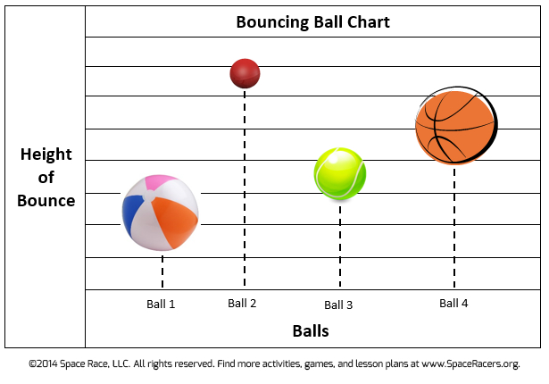

1. The graph is missing some information. Put the missing information in the appropriate place. (1 mark)
2. Which ball is the most efficient? (1 mark)

____________________________________________________________

**Question 3**  **Table Data**  **(9 Marks)**

Another student recorded their data in a table which is shown below. Assume the starting height of the bounce to be 100cm.

_______________________________________________

| Type of ball | First bounce | Second bounce | Third bounce | Average bounce (cm) | Bounce efficiency (%) |
| --- | --- | --- | --- | --- | --- |
| Tennis ball | 17.5 cm | 18.0 cm | 20.5 cm |  |  |
| Golf ball | 39.0 cm | 39.0 cm | 37.0 cm |  |  |
| Ping pong ball | 50.0 cm | 46.0 cm | 52.0 cm |  |  |

* 1. Calculate the average bounce for each type of ball and enter this information into the table. (3 marks)
  2. Calculate the bounce efficiency for each type of ball and enter this information into the table. (3 marks)
  3. The student has made an error in their table. They have missed entering information, and so information has been placed in the wrong place.
     1. Enter the missing information in the space provided. (1 mark)
     2. Circle the information that is in the wrong place and draw an arrow pointing to the area where the information should have been placed.

(2 marks)

**Question 4 Sankey Diagrams**  **(8 Marks)**

Below is a picture of a Sankey Diagram showing the transformations that have occurred during the bouncing of a ball.

1. Fill in the blanks in the following Sankey diagram to show the energy transformations from when you dropped the ball to when it reached its bounce height. (5 marks)

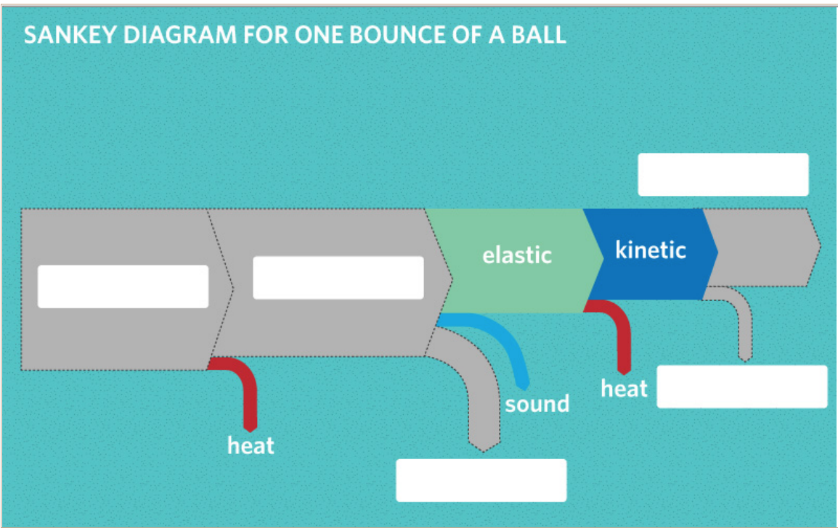

1. Why don't the balls bounce back to their original heights? Do they violate the law of conservation of energy? (3 marks)

________________________________________________________________________________________________________________________________________________________________________________________________________________________________________________________________________________________________________________________________________________________________________________________________________________________________________________________________________________________________________________________________________

**Question 5**  **Energy Efficiency**  **(3 Marks)**

The bounce efficiency was calculated by dividing two heights. Explain why it can be used as a measure of energy efficiency.

Hint: Remember which type of energy is directly related to height. Also, recall that energy efficiency is the useful energy divided by the total input energy. What is the useful energy in this case, given that we want the balls to bounce as high as possible?

________________________________________________________________________________________________________________________________________________________________________________________________________________________________________________________________________________________________________________________________________________________________________________________________________________________________________________________________________________________________________________________________________________________________________________